MAIN PAGE
IMP (INSULATED METAL PANEL) SIDING
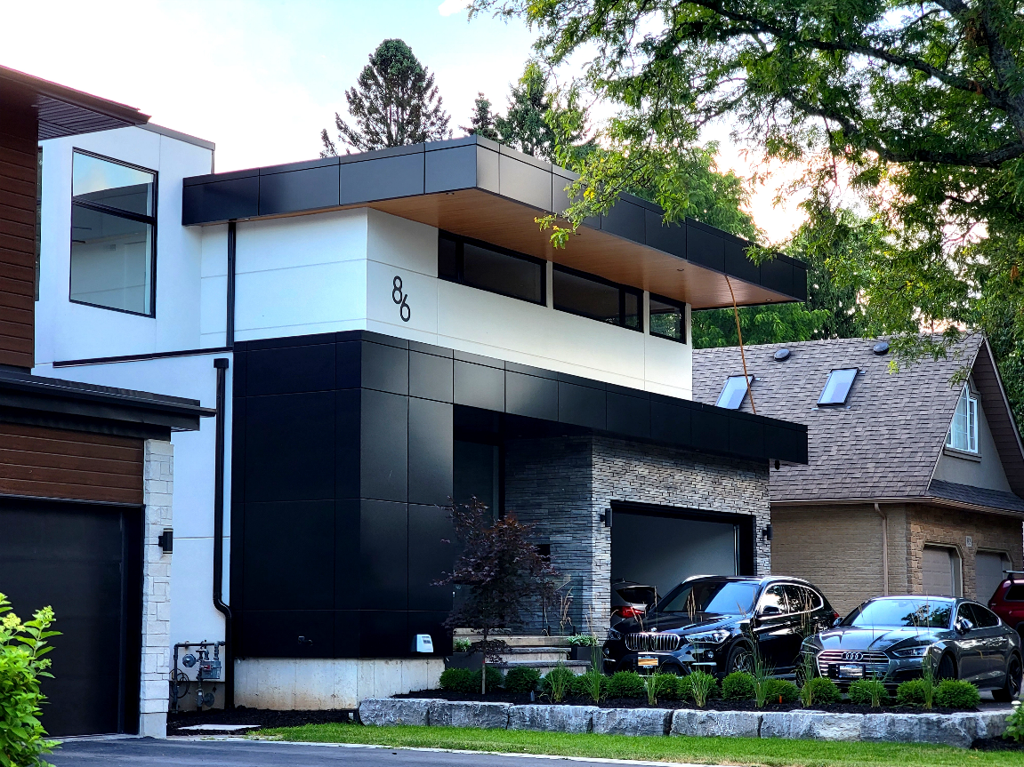
Industrial / Agricultural / Commercial / Cold Storage
What Are Insulated Metal Panels (IMP)?
Insulated Metal Panels (IMPs) are high-performance building envelope components—pre-fabricated panels featuring metal facings bonded to a rigid insulation core. They deliver outstanding thermal efficiency, structural strength, air and moisture tightness, and architectural versatility. With high R-values (up to ~45 in some systems), integral vapor and water barriers, and rapid one-pass installation, IMPs outperform traditional assemblies in speed, cost-efficiency, and building code compliance. They’re increasingly used in everything from cold-storage and industrial facilities to multi-family housing, sports arenas, and designer commercial façades..... (Learn More / Expand)

Advantages and Characteristics of Insulated Metal Panels
1. Exceptional Thermal Efficiency
IMPs combine rigid insulation cores (typically PIR, PUR, or mineral wool) with steel or aluminum facings to deliver very high R-values in a slim profile. This reduces heating and cooling loads, improves energy performance, and can help meet stringent building codes or sustainability goals.
2. Fast and Cost-Effective Installation
Because IMPs integrate structure, insulation, and exterior finish in one panel, they can be installed quickly compared to multi-layered wall assemblies. This reduces labor costs, speeds up project timelines, and minimizes jobsite disruption.
3. Versatility in Applications
These panels are used across many sectors: commercial and institutional buildings, industrial facilities, cold storage and food plants, multi-family housing, agricultural structures, architectural façades, and even roofing systems. They can be installed horizontally or vertically and adapted to different design needs.
4. Integrated Weather and Moisture Protection
Factory-sealed joints and precision connections create continuous air, vapor, and water barriers, helping protect the building envelope from leaks, condensation, and mold.
5. Aesthetic and Design Flexibility
Modern IMPs come in multiple profiles (smooth, striated, ribbed, embossed), colors, and finishes, including PVDF and SMP coatings, wood-grain looks, or metallic effects. They offer clean lines and can be paired with other cladding materials for striking façades.
6. Fire and Safety Performance
Depending on the core type, IMPs can provide fire-resistant ratings of up to several hours. Mineral wool cores, for example, offer non-combustible protection ideal for high-occupancy or fire-regulated projects.
7. Lightweight Yet Strong
Despite their structural integrity and durability, IMPs are relatively light, which reduces the need for heavy framing and can lower transportation and handling costs.
8. Sustainability and Longevity
Many systems incorporate recycled materials, offer long service lives with minimal maintenance, and can contribute to green building certifications (LEED, Net Zero). Durable finishes resist fading, chalking, and corrosion.

Norbec Product Overview (EXPANDED)
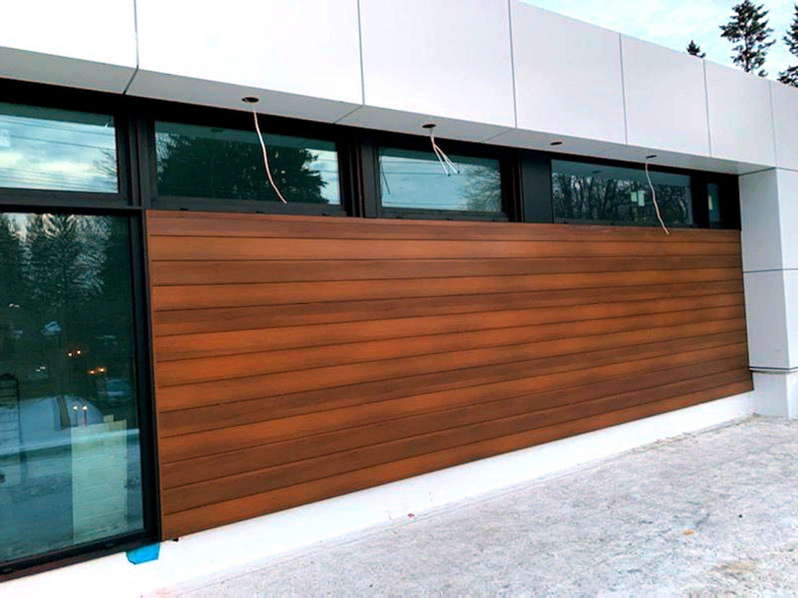
Expanded … Performance Meets Precision
Norbec focuses on delivering panels that combine engineering accuracy with energy efficiency. Their IMP systems are designed to meet the toughest building challenges, from cold storage to architectural façades, without compromising on aesthetics or speed of installation.

Applications & Benefits
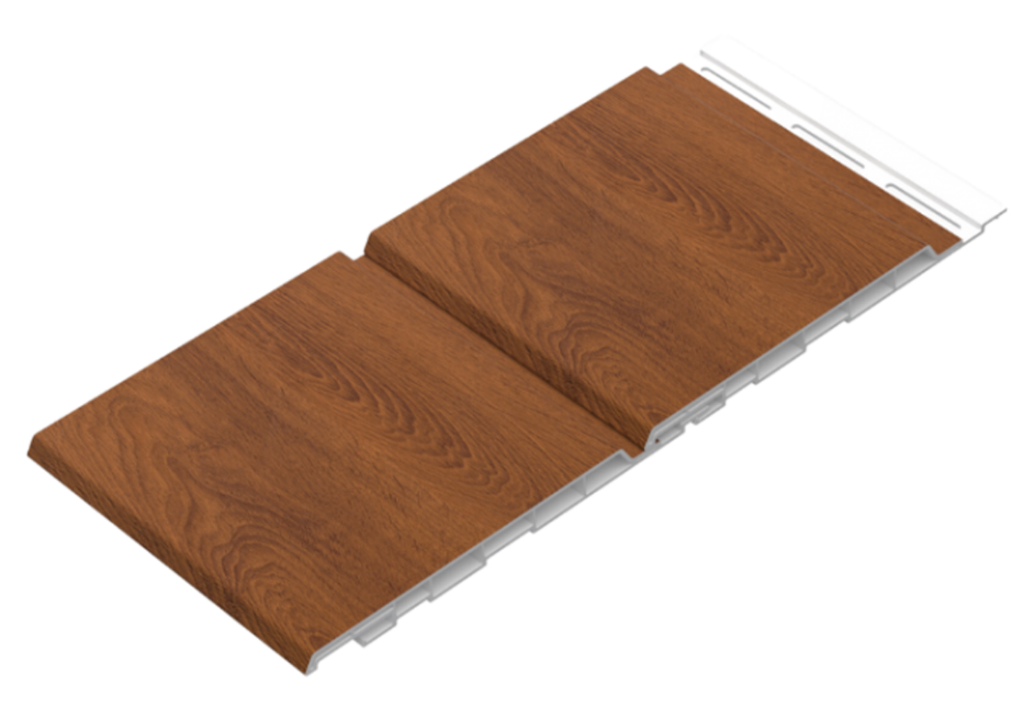

- Ideal for commercial façades, industrial buildings, cold-storage, food facilities, agricultural structures, cleanrooms, and architectural projects.
- Offers excellent thermal insulation, aesthetic versatility, durable construction, and fast, simplified installation.
Technology & Performance
- Product lines like NOREX, NOREX-M, NOROC, and NOREX-IN are engineered for different environments—from fire-rated façades to interior partitions.
- NOREX-L, featuring polyisocyanurate core and pressure-equalized rainscreen joints, delivers over R-8 per inch, exceptional moisture control, and LEED potential.
Product Formats
- Profiles include Silkline, micro-ribbed, fluted, or smooth, with optional architectural FINS for a striking visual impact.

